**Max1000 & Quartus Setup Guide**

**Windows:**

1. Installing Quartus: <http://fpgasoftware.intel.com/18.1/?edition=lite&platform=windows&download_manager=direct>
   1. Download **Quartus Prime, ModelSim-Intel FPGA Edition,** and **MAX 10 FPGA device support before moving on to step c.** 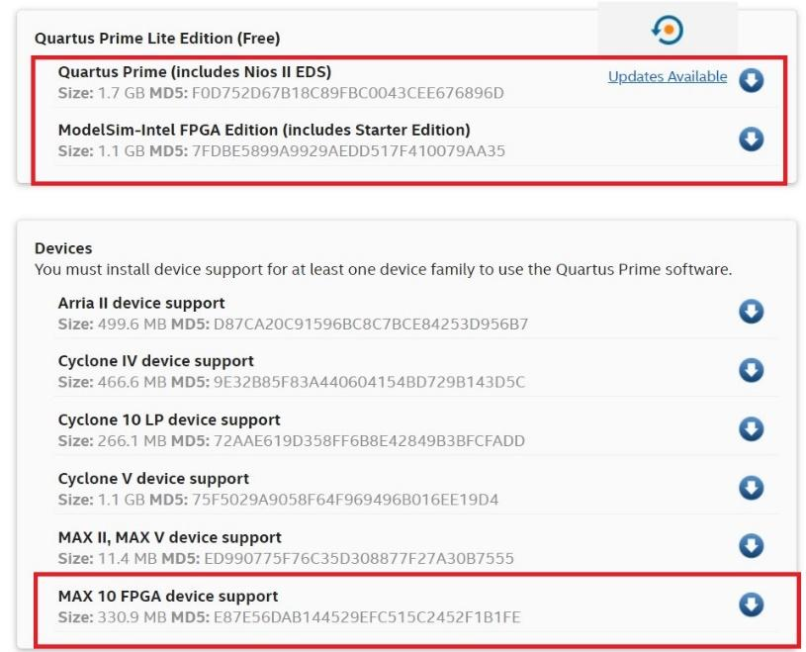

(You’ll have to make an Intel account before you’re able to download anything).

* 1. When creating your Intel account, **MAKE SURE TO FOLLOW INTEL’S PASSWORD GUIDELINES HERE:** <https://www.intel.com/content/www/us/en/my-intel/fpga-sign-in-help.html> If your password doesn’t meet this criteria you will not be able to login.
  2. Run **QuartusProSetup-18.1.0.222-windows.exe** and the installer should hook in the **ModelSim**, and **MAX 10 FPGA device support** installers. If not just run them separately. (At the time this was written, Quartus Lite version 18.1 was used. Now given that Intel updates Quartus regularly, a newer version of Quartus Lite may be available today. Go ahead and use the newest version available. **(MAKE SURE IT IS QUARTUS LITE NOT QUARTUS PRIME**)

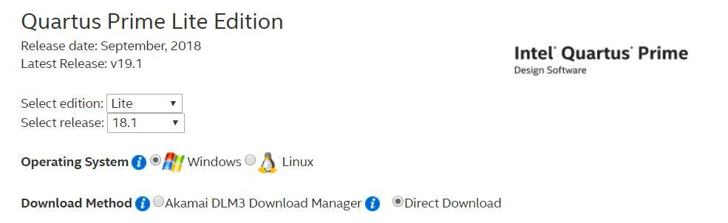

1. Installing Drivers: <https://shop.trenz-electronic.de/Download/?path=Trenz_Electronic/Software/Drivers/Arrow_USB_Programmer/Arrow_USB_Programmer_2.2>
   1. Download and extract the .zip file. (If you cannot access the Arrow Driver from the link provided, ask your instructor to supply you with a copy or check TRACS/CANVAS)
   2. Plug the MAX1000 into your computer via a USB to MicroUSB cable. **Make sure your USB cable is capable of data transfer. The cable is data transferable if you see the FPGA being recognized within the Start Menu >>Device Manager >> Comm Ports. You may see the device as COM6 or COM9. (The COM Depends on PC)**

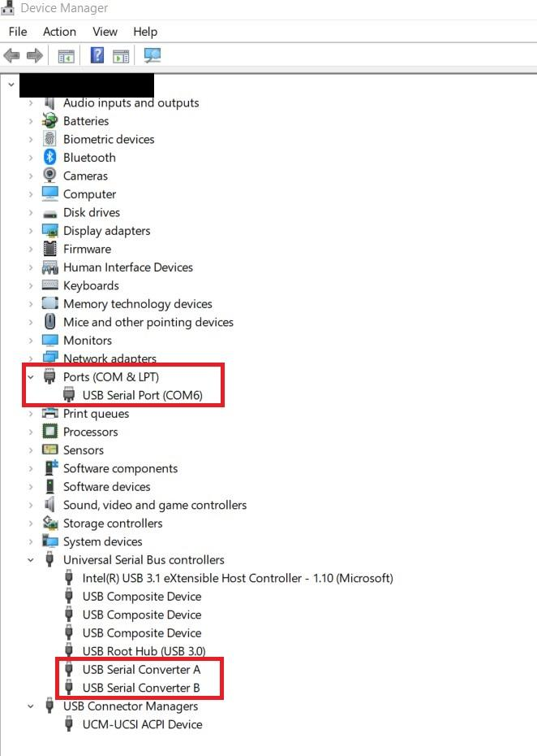

**(Any android cellphone cable is usually a good cable to use. But some cables my vary.)**

* 1. Run **Arrow-USB-Blaster-Setup-2.2.exe** from the .zip file
  2. To check if Quartus is able to see the Max1000 open **Quartus Prime Programmer Lite Edition** by searching for it through Windows start menu. If it doesn’t show up, navigate to **C:\intelFPGA_lite\18.1\quartus\bin64\ and run quartus_pgmw.exe and run it manually.**
     1. Click Hardware Setup
     2. In the table below their will be an entry for Hardware - “Arrow-USB-Blaster” Port – “USBx”.
     3. Double click it and it should show back in the **Quartus Prime Programmer Lite Edition** window.